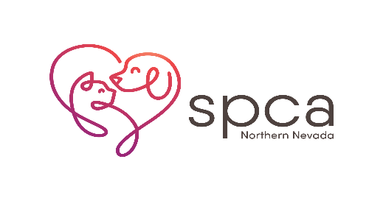
Adoption Interest Form

If you are interested in adopting an SPCA pet not yet available for adoption, please complete the information below. Please understand that the SPCA is only able to put one possible adopter on each animal.
The possible adopter will be called the morning the animal becomes available for adoption. The SPCA team member calling will leave a number and extension for you to call back. If you are called and unable to get through to that number, please call 775-324-7773 ext. 218 (the adoption desk).
Please refer to the Adoption Interest policies on the bottom of this page for further information.

Date ________________________ Current Time _____________________

Animal Name_________________ Animal#_____________ Kennel #____________

Your name:______________________________________________________________________

Phone Number: _______________ Secondary Phone Number: ________________

Are there children in the home? Y/N (circle one) If yes, list ages of children____________
Do you currently have other animals at home? Y/N (circle one)

If so, please fill out below information.

Type of animal Age Indoor/Outdoor? Length of ownership Are they spayed/Neutered?

_________________________________________________________________Yes____No____

_________________________________________________________________Yes____No____

_________________________________________________________________Yes____No____

_________________________________________________________________Yes____No____

SPCA Employee Signature ___________________________________________

Adoption Interest Hold Policies:
- Adoption Interest requests are processed in the order in which they are received.
- No adoption guarantee is expressed or implied.
- While in practice it is rare that we do not place an animal for adoption through the Adoption Interest process, the SPCA reserves the right to determine if an animal is suitable for adoption and alternatively, to work with rescue groups to place animals if we feel it is in their best interest.
- If you are called about adopting the animal, you will need to return to the SPCA Adoption Center to complete the adoption paperwork that day. Standard adoption criteria and fees apply to animals selected through this process.

